Continuous Compliance and Change Management in AWS

- Introduction
In this lab exercise, I implement a continuous compliance and change management solution using Amazon Web Services (AWS). The purpose of this lab is to demonstrate how cloud resources are continuously monitored, how security misconfigurations are detected automatically, and how real-time alerts are generated when compliance violations occur.
I configure AWS Config to monitor changes within my AWS environment and to evaluate AWS resources against predefined compliance rules. I also configure Amazon Simple Notification Service (SNS) to send email notifications whenever a non-compliant configuration is detected. The compliance scenario used in this lab focuses on Amazon S3 buckets, where public read access is treated as a security risk.

2. Overview of AWS Services Used

- AWS Config: AWS Config is the service I use to record and evaluate configuration changes within my AWS account. It monitors supported AWS resources and compares their configurations against defined compliance rules. AWS Config also maintains a configuration history and resource timeline that supports investigation and auditing activities. AWS Config serves as the primary compliance monitoring service.

- Amazon Simple Notification Service (SNS): Amazon Simple Notification Service (SNS) is the service I use to deliver real-time notifications. It sends email alerts to my inbox whenever AWS Config detects a compliance violation. In this lab, SNS functions as the alerting and communication mechanism.

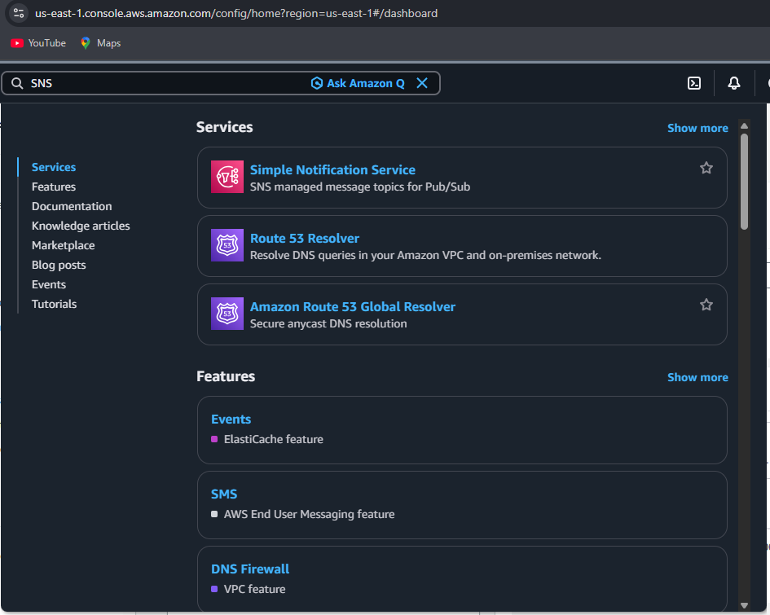

- Amazon S3: Amazon S3 is the AWS service monitored for compliance. I intentionally modify the configuration of an S3 bucket to allow public read access in order to trigger a non-compliance event and test the monitoring and alerting setup.

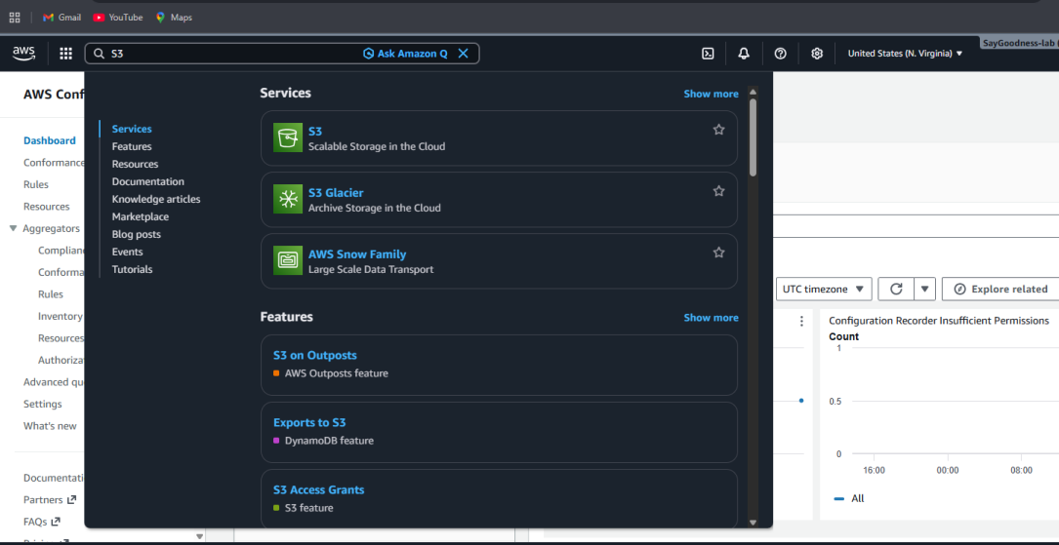

3. AWS Account and Initial Setup
I log into my AWS account through the AWS Management Console and ensure that the selected region is US East (N. Virginia) so that all services operate within the same region. I create and use an IAM user with administrative permissions instead of the root account, in line with AWS security best practices.
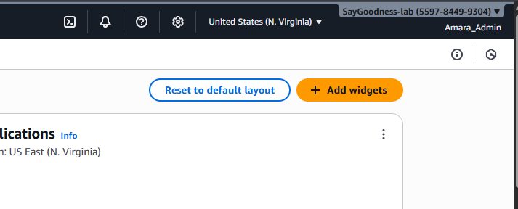

4. Configuring AWS Config
I navigate to the AWS Config service from the AWS Management Console and start the configuration process. I select the option to record all supported resource types within the selected region so that configuration changes across the environment are monitored. I allow AWS Config to automatically create an IAM role with the required permissions. I also create a new Amazon S3 bucket to store configuration history and compliance snapshots generated by AWS Config. At this stage, I do not configure an SNS topic within AWS Config. After reviewing the configuration settings, I enable AWS Config and allow time for the service to initialize.

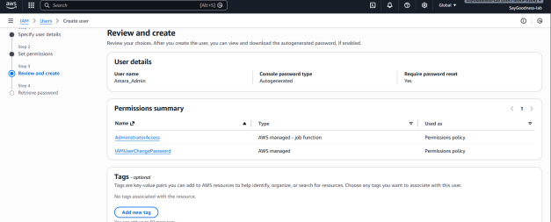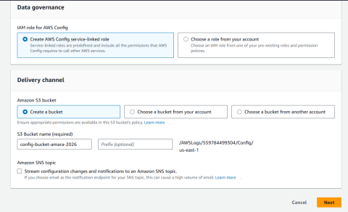

5. Configuring Amazon SNS for Alerts
I navigate to the Amazon SNS service and create a standard SNS topic named SecurityAlertsTopic. This topic acts as the central channel for security notifications.
I create an email subscription for the topic and enter my personal email address as the endpoint. I confirm the subscription using the confirmation link sent to my email, which enables SNS to deliver notifications.

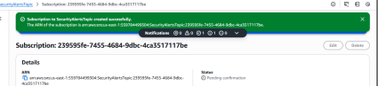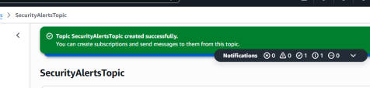

6. Adding the Compliance Rule and Linking SNS
I return to AWS Config and navigate to the Rules section. I add the AWS-managed rule s3-bucket-public-read-prohibited, which evaluates whether any S3 bucket allows public read access. I then update the AWS Config delivery channel to include the SecurityAlertsTopic SNS topic. This ensures that AWS Config sends notifications to SNS whenever a compliance status change occurs.

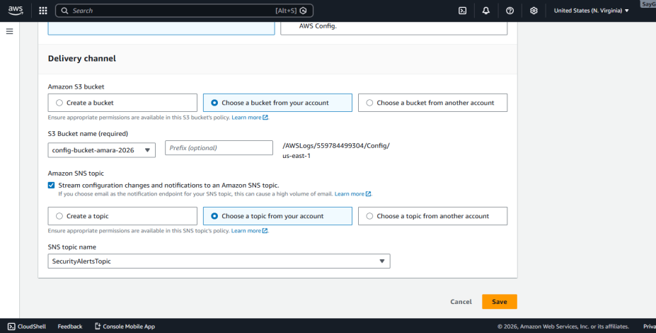

7. Triggering a Non-Compliant Event (Break Phase)
To test the configuration, I create a new Amazon S3 bucket named test-public-bucket-amarachi. I disable the “Block all public access” setting and allow public read access, which violates the compliance rule. After a short delay, AWS Config detects the configuration change and marks the resource as non-compliant. The compliance rule status changes to red (Non-compliant), confirming that the violation is successfully detected.

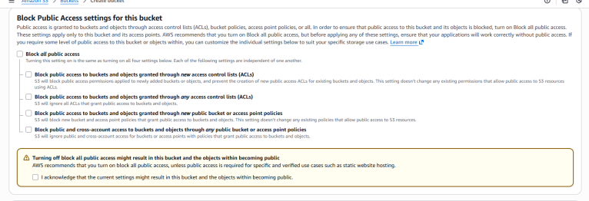

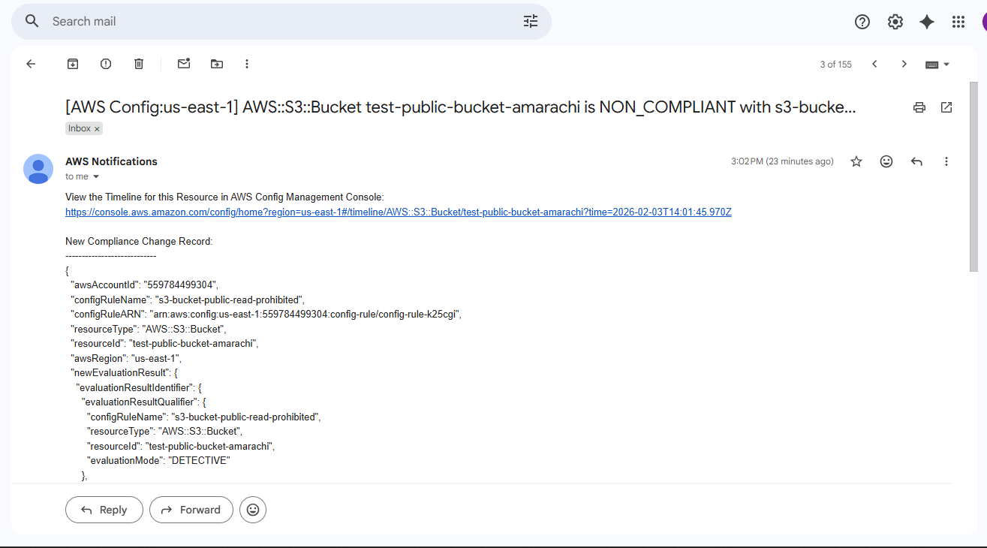
SNS Email Alert Showing S3 Bucket Public Access Violation

8. Investigating the Compliance Violation
I navigate to the AWS Config Resource Inventory and select the affected S3 bucket. I open the Resource Timeline to review the sequence of configuration changes. The timeline shows the exact time the bucket becomes public and when the compliance rule evaluates the resource as non-compliant. This step demonstrates how AWS Config supports auditing and investigation through detailed visibility into resource changes.
s
